**Name: Muhammad Ethisham**

**Roll Number: KWOWFL3434**

**Assignment:04**

**How to duplicate repeating items inside a Dart list?**

**Problem**

**Consider the code:**

**final List<Dynamic> _nameList = [Bilal, Bilal, Bilal, Owais, Owais,**

**Owais]**

**What can to be done in order to not repeat Bilal and Owais multiple**

**times?**

We can use Set() method and foreach loop in order to stop repeating the same items of the list

void main()

{

final List<dynamic> _nameList = ["Bilal", "Bilal", "Bilal", "Owais", "Owais","Owais"];

_nameList.toSet().forEach((item) => {_nameList.remove(item)});

print(_nameList.toSet().toList());

}

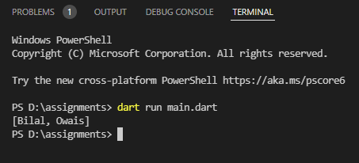

**Let’s say you are given a list saved in a variable:**

**Consider a = [1, 4, 9, 16, 25, 36, 49, 64, 81, 100].**

**Write a code that takes this list and makes a new list that has only the**

**even elements of this list in it.**

void main()

{

List a=[1, 4, 9, 16, 25, 36, 49, 64, 81, 100];

int i=0;

print([for (var e in a) if (++i % 2 == 0) e]);

}

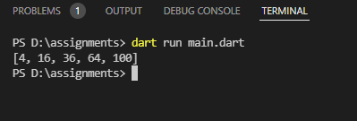

**Ask the user for a number and determine whether the number is**

**prime or not.**

import 'dart:io';

void main()

{

print('Enter Number to Check is Prime or Not:');

int numm=int.parse((stdin.readLineSync()!));

int fac=0;

for (int i=1;i<=numm;i++)

{

if(numm%i==0)

{

fac++;

}

}

if (fac <= 2) {

print('$numm is prime.');

}

else {

print('$numm is not prime.');

}

}

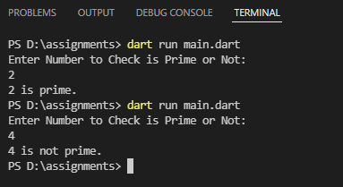

**Write a program to print multiplication table of 7 length 15 using loop.**

void main()

{

print('--------Table of 7---------');

for (int i=1;i<=15;i++)

{

print("7*$i=${i*7}");

}

}

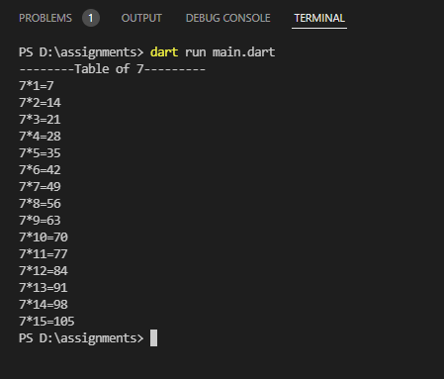

**Write a program to print items of the following array using for loop: fruits = [“apple”, “banana”, “mango”, “orange”, “strawberry”].**

void main()

{

List fruits=["apple", "banana", "mango", "orange", "strawberry"];

print("The items in Array are:");

for(int i=0;i<fruits.length;i++)

{

print(fruits[i]);

}

}

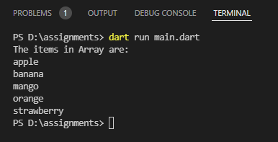

**Write a program to print multiples of 5 ranging 1 to 100.**

void main()

{

print("The Multiples of 5 in range 1 to 100 are:");

for(int i=1;i<=100;i++)

{

if(i%5==0)

{

print(i);

}

}

}

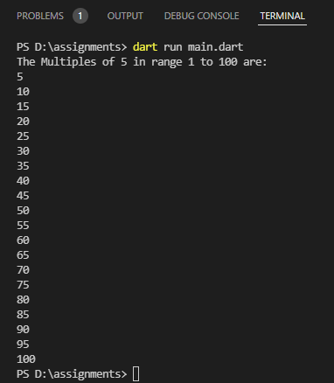

**The Temperature Converter: It’s hot out! Let’s make a converter**

**based on the steps here.**

**a. Store a Celsius temperature into a variable.**

**b. Convert it to Fahrenheit & output “NNoC is NNoF”.**

**c. Now store a Fahrenheit temperature into a variable.**

**d. Convert it to Celsius & output “NNoF is NNoC”.**

import 'dart:io';

void main()

{

print("Enter Temperature in `C:");

double temp=double.parse(stdin.readLineSync()!);

double farenheit= (temp*1.8)+32;

print("$temp`C is $farenheit`F");

print("Enter Temperature in `F:");

double temp1=double.parse(stdin.readLineSync()!);

double celcius= (temp1-32)*(5/9);

print("$temp1`F is $celcius`C");

}

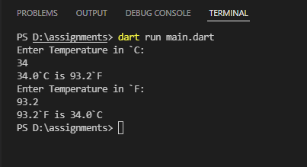

**Write a program to create a calculator for +, -, *, / & % using if**

**statements. Take the following input:**

**a. First number Second number**

**b. Operation (+, -, *, /, %)**

**Compute & show the calculated result to user.**

import 'dart:io';

void main()

{

print("Enter First Number:");

double num1=double.parse(stdin.readLineSync()!);

print("Enter Second Number:");

double num2=double.parse(stdin.readLineSync()!);

print("Enter your Operation to Perform Add(+) ,Sub(-) , Multiplication(*) ,Division(/) ,Remainder(%) ");

String choice=stdin.readLineSync()!;

if(choice=="+")

{

double add=num1+num2;

print("Addition of two numbers:$add.");

}

else if(choice=="-")

{

double sub=num1-num2;

print("Subtraction of two numbers:$sub.");

}

else if(choice=="*")

{

double mul=num1*num2;

print("Multiplication of two numbers:$mul.");

}

else if(choice=="/")

{

double div=num1/num2;

print("Division of two numbers:$div.");

}

else if(choice=="%")

{

double mod=num1%num2;

print("Remainder of two numbers:$mod.");

}

else

{

print("Invalid Choice");

}

}

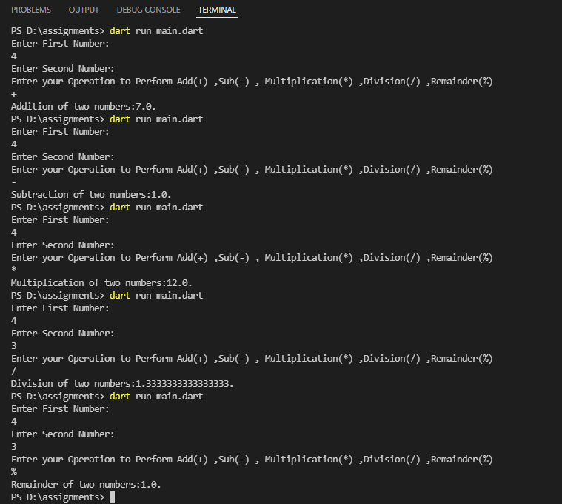

**Write a program to reverse a string. For example, if my string is**

**"natsikaP nawaJ" then my result will be "Jawan Pakistan".**

void main()

{

String a = "natsikaP nawaJ";

a = a.split("").reversed.join("");

print(a);

}

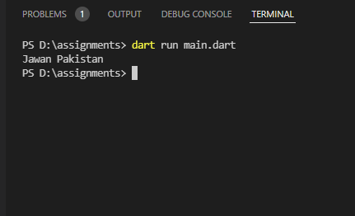

**How are duplicates removed from a given array? [Ahmed, Bilal, Muhammad, Owais, Muhmmad, Ali, Ahmed]**

First we initialized a variable called list to an array that contains some duplicates, then we converted it to a set(as sets cannot contain duplicates) and then back to a list.

void main()

{

List arr=['Ahmed', 'Bilal', 'Muhammad', 'Owais', 'Muhmmad', 'Ali', 'Ahmed'].toSet().toList();

print(arr);

}

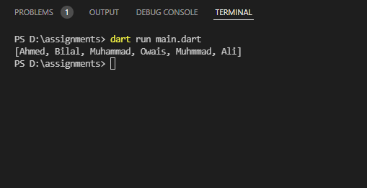

**Find the missing number in array of 1 to 100?**

Iterable<int> findMissingInts(List<int> arr) sync* {

for (var i = 0; i < arr.length - 1; i++) {

for (var j = arr[i] + 1; j < arr[i + 1]; j++) {

yield j;

}

}

}

void main() {

print("Missing Number:${findMissingInts([1,2,4,5,6,7,9,11,100])}");

}

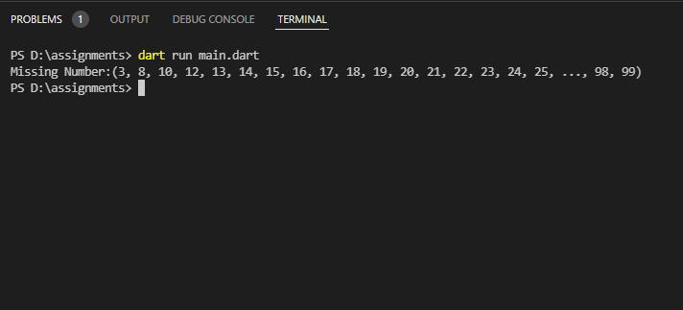

**Find the largest and smallest number in an unsorted integer array?**

void main() {

var arr = [1, 12, 33, 45, 3];

var largest = arr[0];

var smallest = arr[0];

for(var i=1;i<arr.length-1;i++)

{

if (arr[i] > largest) {largest = arr[i];}

else if (arr[i] < smallest) {smallest = arr[i];}

}

print("Smallest value in the list : $smallest");

print("Largest value in the list : $largest");

}

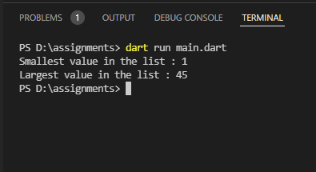

**Find all pairs of an integer array whose sum is equal to a given number?**

void main() {

List<int> arr=[1,5,7,-1,5];

int a=arr.length;

int sum=6;

int count=0;

for(int i=0;i<a;i++)

{

for (int j = i + 1; j < a; j++)

{

if ((arr[i] + arr[j]) == sum)

{

count=count+1;

}

}

}

print("All pairs whose sum is $sum are: $count");

}

